**PROVIDING PREVENTIVE MEASURES BY IDENTIFYING PLANT LEAF DISEASES**

**P. Sai Kiran*1, Y. Sravani*2, P.G.L. Sahithi*3, G. Madhu Babu*4, Md. Wajjahtullah*5**

*1Department of Computer Science, Velagapudi Ramakrishna Siddhartha Engineering College,

Vijayawada, Andhra Pradesh, India

*2Department of Computer Science, Velagapudi Ramakrishna Siddhartha Engineering College,

Vijayawada, Andhra Pradesh, India

*3Department of Computer Science, Velagapudi Ramakrishna Siddhartha Engineering College,

Vijayawada, Andhra Pradesh, India

*4Department of Computer Science, Velagapudi Ramakrishna Siddhartha Engineering College,

Vijayawada, Andhra Pradesh, India

*5Department of Computer Science, Velagapudi Ramakrishna Siddhartha Engineering College,

Vijayawada, Andhra Pradesh, India

**ABSTRACT**

The main aim of this project is to identify the diseases a plant leaf is suffering from so that we can give clear instruction to the farmer about the disease and the measures to be taken using CNN thereby reducing the economical losses. The Plant diseases effect the growth of the crop and reduces the quality of production. Convolutional neural networks helps in identification of features from the input images without the intervention of humans. Convolutional neural networks contains different layers and in each layer there are different activation function called neurons and have an impact on input image at each layer for the feature identification and disease detection. Based on the disease certain prevention measures are insisted to the farmers. Neural networks are used because of their great impact in the image classification.

**KEYWORDS**: Deep Learning, Conventional Neutral Network.

__________________________________________________________________­­­­­­­­­­_________

1. **INTRODUCTION**

Most plant illnesses – around 85 percent – are brought about by parasitic or contagious like creatures. In any case, different genuine sicknesses of food and feed crops are brought about by viral and bacterial living beings. Certain nematodes likewise cause plant ailment. Some plant sicknesses are delegated "abiotic," or ailments that are non-irresistible and incorporate harm from air contamination, nourishing insufficiencies or poison levels, and develop under not exactly ideal condition.

An indication of plant infection is physical proof of the microbe. For instance, parasitic fruiting bodies are an indication of infection. At the point when you take a gander at fine mold on a lilac leaf, you're really taking a gander at the parasitic contagious sickness living being itself. Bacterial blister of stone organic products causes gummosis, a bacterial exudate rising up out of the ulcers. The thick, fluid exudate is fundamentally made out of microscopic organisms and is an indication of the ailment, in spite of the fact that the ulcer itself is made out of plant tissue and is a manifestation.

In this examination, an assortment of neuron-wise and layer-wise representation techniques were applied utilizing a CNN, prepared with a dynamic. While a few representation strategies were utilized as they may be, others must be enhanced to focus on a particular layer that completely catches the highlights to produce significant yields.

Additionally, by deciphering the created consideration maps, we recognized a few layers that were not adding to deduction and eliminated such layers inside the system, diminishing the quantity of boundaries by 75% without influencing the arrangement precision. The outcomes give a stimulus to the CNN discovery clients in the field of plant science to all the more likely comprehend the determination cycle and lead to promote productive utilization of profound learning for plant malady finding.

An indication of plant illness is an obvious impact of infection on the plant. Indications may remember a perceivable change for shading, shape or capacity of the plant as it reacts to the microorganism freely accessible plant illness picture dataset. We demonstrated that neural systems can catch the hues and surfaces of sores explicit to separate sicknesses upon analysis, which looks like human.

1. **LITERATURE SURVEY**

Anandhakrishnan MG Joel Hanson, Annette Joy, Jerin Francis3[1] proposed a hypothesis in regards to plant leaf illness location utilizing Deep Learning and Convolutional Neural Networks. At the point when plants and yields are impacted by bugs it influences the farming creation of the nation. Generally ranchers or specialists watch the plants with unaided eye for recognition and distinguishing proof of illness. Be that as it may, this strategy can be time handling, costly and off base.

MG Joel Hanson, Annette Joy, Jerin Francis3[1] proposed a hypothesis in regards to plant leaf illness location utilizing Deep Learning and Convolutional Neural Networks. At the point when plants and yields are impacted by bugs it influences the farming creation of the nation. Generally ranchers or specialists watch the plants with unaided eye for recognition and distinguishing proof of illness. Be that as it may, this strategy can be time handling, costly and off base.

This paper is worried about another way to deal with the advancement of plant sickness acknowledgment model, in light of leaf picture characterization, utilizing profound convolutional systems. In any case, the difficult we saw in their examination is that they have utilized Database for putting away pictures of sick leaves. This strategy is reasonable for hiding away to some degree of datasets yet with regards to neural systems it is hard to get to the pictures and train them utilizing database. Along these lines, we have thought of an answer of making a different arrangement of records for each yield in which we can recover train and store the pictures without the assistance of database.

KonstantinosP.Ferentinos, Hellenic Agricultural Organization "Demeter", Institute of Soil and Water Resources, Dept. of Agricultural Engineering, 61 Dimokratias Av., 13561 Athens, Greece[2] Worked on the comparative theme with respect to plant sickness discovery utilizing CNN. In this paper, convolutional neural system models were created to perform plant ailment location and determination utilizing straightforward leaves pictures of sound and sick plants, through profound learning techniques.

KamleshGolhani, Siva K.Balasundram, GanesanVadamalai, BiswajeetPradhan[3] combinedly worked and proposed an alternate methodology of Plant illness discovery utilizing a progressed Neural Network(NN) procedures accessible to process hyperspectral information, with a unique accentuation on plant ailment identification. Right off the bat, they give a survey on NN component, types, models, and classifiers that utilization various calculations to process hyperspectral information. At that point they feature the present status of imaging and non-imaging hyperspectral information for early malady identification.

MelikeSardogan, AdemTuncer, YunusOzen[4] summed up a method on early harvest sickness identification for an effective harvest yield. Programmed techniques for grouping of plant ailments additionally help making a move subsequent to distinguishing the indications of leaf ailments. This paper presents a Convolutional Neural Network (CNN) model and Learning Vector Quantization (LVQ) calculation based strategy for tomato leaf malady discovery and grouping. The dataset contains 500 pictures of tomato leaves with four side effects of ailments. This work of them gave us a thought regarding picture preparing and preparing of pictures while distinguishing a harvest ailment. Like the hypothesis they proposed we utilized a lot of 500 pictures for handling a harvest identification.

AniketGharat, Krupa Bhatt, BhaveshKanase&AbhilashaBapnna[5] a group of experts chipped away at the procedure of leaf ailment location utilizing Image Processing. Leaf sickness identification is fundamentally a web application which make an employments of picture preparing and convolution neural system. For this reason, Feature extraction of picture will be performed. In Feature extraction we use shading (HSI model). The infection is characterized by utilizing convolution neural system.

The framework utilizes two picture databases, one for preparing of previously put away ailment pictures and the other for usage of question pictures. In the wake of investigating their work, we have reasoned that they utilized JAVA for usage and OPENCV library for handling up the pictures. In any case, the thing is OPENCV functions admirably for novel arrangement of pictures as it is generally utilized for Facial acknowledgment and it isn't exact for recognition of comparative sort of pictures. In leaf sickness location we may have comparative sort of leaves, so working with such a stage and library is beyond the realm of imagination.

Jayme Garcia ArnalBarbedo[6] have announced a hypothesis on plant ailment recognition which works with various kinds of plants and their illnesses alongside utilizing predetermined number of datasets. By and large, this sort of procedure requires huge datasets containing a wide combinations of conditions to work appropriately. This is a significant constraint, given the numerous difficulties associated with the development of an appropriate picture database. In this specific situation, this examination researches how the size and assortment of the datasets sway the viability of profound learning strategies applied to plant pathology. This technique is viable as it can recognize 56 infections tried on 12 plant species. So we utilized comparable methodology however with more datasets as we focused much on quality as opposed to amount, so as to expand exactness.

Saiqa Khan, Meera Narvekar,Anam Ayesha Shaikh, Hera Ansari, Nida Ansari[7] proposed a hypothesis on plant sickness ID in tomato crop. This paper proposes a profound learning-based methodology that robotizes the way toward characterizing tomato leaves sicknesses. The proposed framework centers around significant infections like early curse, fine buildup and fleece mold that happen in tomato plants.

We utilize Convolution Neural Network to group the picture informational indexes dependent on the noticeable impacts of illnesses. Not at all like Image Processing, Deep Learning learns and adjusts to the changing informational collections. The proposed philosophy will utilize an assorted dataset that incorporates pictures from the nursery, plant town, and ranch. This task got the majority of the precise rate in infection identification and proposal of cures as they are chipping away at a solitary harvest. We utilized comparable methodology for location of illness in tomato crop and furthermore for cures.

1. **METHODOLOGY**

The entire procedure of developing the model for plant sickness identification using deep CNN is described in steps as follows. The complete process is divided into several stages, starting with gathering images for classification, process using deep neural networks.

**3.1 Dataset**

Appropriate datasets are required for training the data and assessing the exhibition of the algorithms. All the images collected for the dataset are accessible from the internet. Images in the dataset were grouped into fifteen different classes. Thirteen classes represented plant diseases which could be visually determined from leaves.

So as to separate the sound leaves from infected ones, one more class was included the dataset. It contains just pictures of sound leaves. An additional class in the dataset with foundation pictures was advantageous to get more precise grouping. Following stage was to enhance the dataset with increased pictures that may be turning the picture, shearing , incorporate even and vertical flips .

The primary objective of the introduced investigation is to prepare the system to get familiar with the highlights that recognize one class from the others. In this way, when utilizing more enlarged pictures, the possibility for the system to get familiar with the fitting highlights has been expanded. Finally, a database containing 15000images for training and 7500 images for validation has been created.

Table shows all supported diseases together with the number images for every class used as training and validation dataset for the disease classification model.

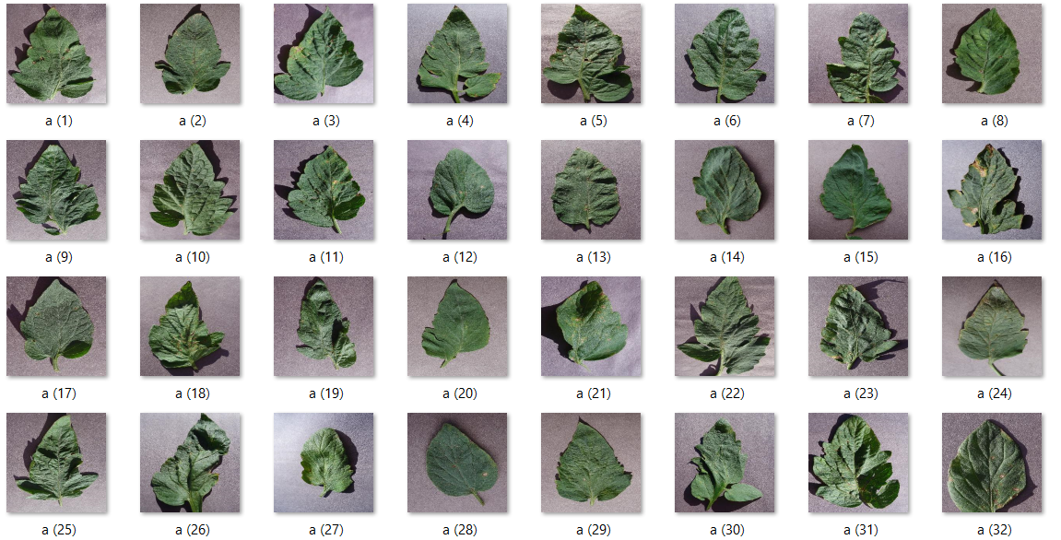

**Fig-1: Showing Dataset of leaves**

**3.2 Image Pre-Processing**

Images saved from the Internet are of different resolutions and pixels. In order to get better feature extraction, the images are processed that include cropping of all the images into a particular size say 256X256. During the phase of collecting the images for the dataset, images with smaller resolution and dimension less than 200 px were not considered as valid images for the dataset. In addition, only the images where the region of interest was in higher resolution were included in the dataset. In this way, it was ensured that images contain all the needed information for learning the features. Images used for the dataset were image resized to 256X256 thereby reduce the time of training, which was automatically computed by written in Python, using the OpenCV .To affirm the precision of classes in the dataset, rural specialists inspected leaf pictures and named all the pictures with proper infection. It is imperative to utilize precisely arranged pictures for the training.

**3.3 Neural Network Training**

Training the deep convolutional neural network for making an image classification model from the above described dataset. There are several predefined deep learning frameworks having different layers and different number of neurons at each layer. TFLearn is a deep learning framework which is built on top of Tensorflow.

The CNN which has multiple layers that progressively compute features from input images. The network contains the convolution base and the classifier. The classifier contains the convolutional layer followed by pooling layer which helps to extract the low level features of the image and classifier classifies the images in to different categories based on the combination different low level features into high level features. The Model contains five convolutional layer with RELU activation function and one fully connected layers with softmax activation.

This network is the starting point, but modified and adjusted to support our 15 categories (classes).In the last layer, the softmax layer output was parameterized to the requirements of present study.

The first layer is convolutional layer and it is the essential building block of the convolutional neural network. The layer’s parameters are comprised of a set of learnable kernels. Each convolutional layer has  maps of equal size,  and , and a kernel of size , and  is shifted over the input image. The size of output map is same for all the feature maps .

Rectified Linear Units (ReLU) are used for saturating nonlinearities. This activation function learns the parameters from input images and helps in increasing the accuracy.

In CNN, neurons within a hidden layer extracts the feature maps. The neurons in a feature map share the same weight and bias. The neurons with a feature map search for the same feature. These neurons are unique since they are connected to different neurons in the lower layer. So the neurons in the hidden layers are connected to the same feature in a different region of the image. In this layers based on features, features maps are created. Basically, the feature map is the result of applying convolution across an image.

Another important layer of CNNs is the pooling layer, its is used to shrink the input image inorder to reduce the computational load, the memory usage, and the number of parameters.pooling layer resizes the image. Overlapping pooling is beneficially applied to lessen overfitting. Also in favour of reducing overfitting, a dropout layer is used in the first fully connected layers. But the shortcoming of dropout is that it increases training time 2-3 times comparing to a standard neural

The Fully connected layer is used to classify the output of the image using the softmax activation. After the softmax layer, we have the ouput probabilities of different classes. The class with maximum probability is output.

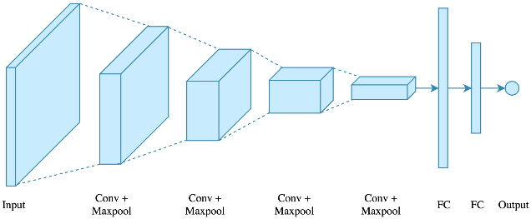

**Fig-2: Convolutional neural networks architecture**

**3.4 Training**

The approach in measuring the performance of neural networks is splitting data into the training set and test set and then training a neural network on the training set helps in predicting the output of the test set. Thus, since the original outcomes for the testing set and our model predicted outcomes are known, the accuracy of our prediction can be calculated. Different tests were performed with 7500 original images, when trained with 15000 images from dataset.

For the accuracy test, 10-fold cross validation was used to evaluate a predictive model. The cross validation procedure was repeated after every thousand training iteration. Overall estimated result of the test is graphically represented as top-1, to test if the top class (the one having the highest probability) is the same as the target label. The number of images used for the validation test from each labelled class is defined from the training set.

The process of fine-tuning was repeated changing parameters of hidden layers and hyperparameters through back propagation. The best suited model for plant disease detection was achieved through the process of experimental adjustment of the parameters.

**3.5 Equipment**

A single PC was used for the entire process of training and testing the plant disease detection model described in this paper. Training of the CNN was performed in CPU mode. Every training iteration took approximately hours on this specified machine.

1. **RESULTS & DISCUSSIONS**

The results presented in this section are related to training with the whole dataset containing both original and augmented images. As it is known that convolutional networks are able to learn features when trained on larger datasets, results achieved when trained with only original images will not be explored.

After fine-tuning the parameters of the network, an overall accuracy of 96.3% was achieved, after the training (95.8% without fine-tuning). The green line in the graph in shows the network’s success on the validation loss occured through training iterations. After every 10 thousand training iterations, the snapshot of the model was obtained. The blue line in the graph represents the loss during the training stage. Through training iterations, loss was rapidly reduced.

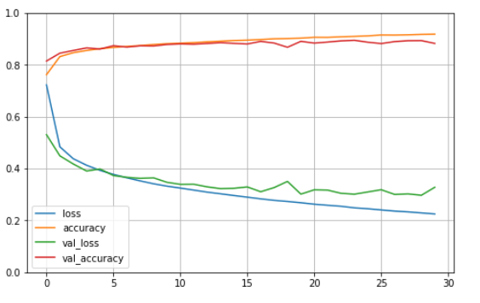

**Fig-3:**

From the results ,  it is notable that the trained model’s accuracy was slightly less for classes with lower number of images in the training dataset. High accuracy of model’s prediction of background images allows good separation of plants leaves and the surroundings.

**4.1 Output**

To display the output, we have used the Tkinter module in python to diplay the results in the GUI. By using the buttons ,you can know what are the measures to be taken inorder to prevent the spread of the disease and what are pesticides to be used .

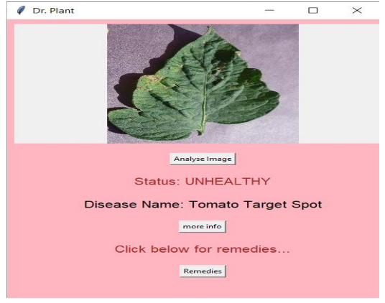 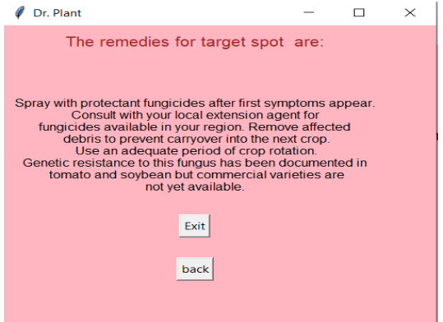

**Fig-4: Displaying name of the plant disease Fig-5: Showing the remedies**

#### CONCLUSION

The approach of using deep learning method helps us to automatically classify and detect leaf diseases from leaf images. The developed model is used to detect leaf presence and distinguish between healthy leaves and 13 different diseases, which can be visually diagnosed. The complete procedure described from collecting the images used for training and validation to image pre-processing and augmentation and finally the procedure of training the deep CNN and fine-tuning. Different tests were performed in order to check the performance of newly created model... The final overall accuracy of the trained model was 96.3%.

The goal for the future work will be developing a complete system consisting of server side components containing a trained model and an application for smart mobile devices by displaying the recognized diseases in various other plants , based on leaf images captured by the mobile phone camera. This application will serve as an aid to farmers enabling fast and efficient recognition of plant diseases and facilitating the decision-making process when it comes to the use of chemical pesticides.

**VI. REFERENCES**

[1] https://towardsdatascience.com/covoluti onal-neural-network-cb0883dd6529.

[2] Gupta,Dishashree. "Architecture of convolutional neural networks (CNNs) demystified." Analytics Vidhya (2017).

[3] Ferentinos, Konstantinos P. "Deep learning models for plant disease detection and diagnosis." Computers and Electronics in Agriculture 145 (2018): 311-318.

[4] [https://pdfs.semanticscholar.org/2163/f 1c](https://pdfs.semanticscholar.org/2163/f%201c)76e8d8d17d5e6759f6bae10165706a1dd.pdf

[5] Golhani, Kamlesh, et al. "A review of neural networks in plant disease detection using hyperspectral data." Information Processing in Agriculture 5.3 (2018): 354-371.

[6] Sardogan, Melike, AdemTuncer, and YunusOzen. "Plant leaf disease detection and classification based on CNN with LVQ algorithm." 2018 3rd International Conference on Computer Science and Engineering (UBMK).IEEE, 2018.

[7] Gharat, Aniket et al. “Leaf Disease Detection Using Image Processing.” (2017).

[8] Bhatia G.S., Ahuja P., Chaudhari D., Paratkar S., Patil A. (2020) Plant Disease Detection Using Deep Learning. In: Smys S., Senjyu T., Lafata P. (eds) Second International Conference on Computer Networks and Communication Technologies. ICCNCT 2019. Lecture Notes on Data Engineering and Communications Technologies, vol 44. Springer, Cham